Experiment No: 04
Experiment Name: Introduction to MDA-8086 Trainer Kit

Theory: The MDA-8086 is an Intel 8086-based microprocessor trainer kit manufactured by MIDAS Engineering for learning assembly language programming and hardware interfacing. It features a 16-bit CPU with a 20-bit address bus and a 16-bit data bus, providing 1 MB of addressing capability for memory and I/O operations. The kit contains EPROM to store the monitor program and RAM to store user-written programs for execution. Input is provided through a hexadecimal keypad with digits 0–9 and A–F, along with function keys like GO, STP, REG, MON, DA, and AD for system control. Output devices include four LEDs, a seven-segment display, an 8×8 dot matrix display, a 16×2 LCD, and a speaker for visual and audio feedback. Since the 8086 microprocessor does not have built-in GPIO ports, the 8255 Programmable Peripheral Interface is essential for connecting the CPU to external hardware devices. The trainer kit uses two 8255 chips, where CS2 controls LEDs, seven-segment displays, and stepper motors, while CS1 manages dot matrix displays and ADC/DAC interfaces. The 8255 contains four internal registers: Port A, Port B, Port C, and a control register for configuring I/O direction and operation modes. Programs are written in assembly language, assembled into machine code, and entered into the monitor program using the keypad for direct execution. The power section includes an ON/OFF switch with a power LED and a reset switch to restart the processor from the beginning of a program. Function keys like GO execute programs from a specified address, while STP enables single-step execution for debugging purposes. This standalone trainer kit provides a complete hands-on platform for understanding microprocessor architecture, memory management, peripheral interfacing, and real-time hardware control without requiring a personal computer.
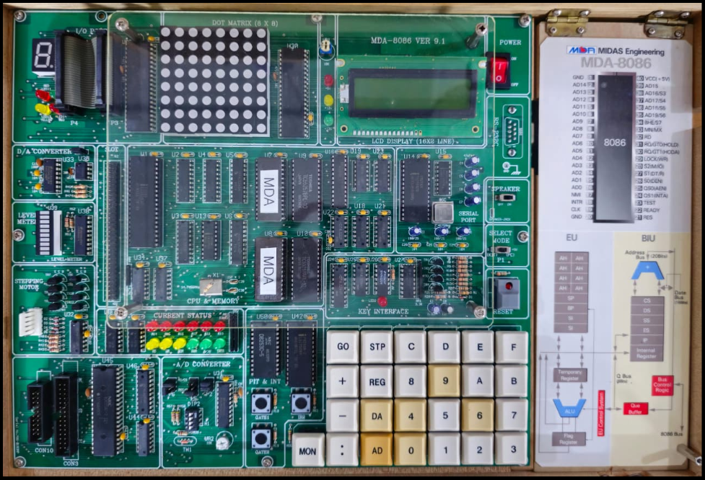

Fig: MDA-8086 Trainer Kit

Manufacturer: MIDAS Engineering
Model: MDA-8086 Version 9.1

Component Details:

Intel 8086 Microprocessor Based Trainer: A complete hands-on learning platform built around the 8086 architectures for studying hardware behavior and assembly language programming.
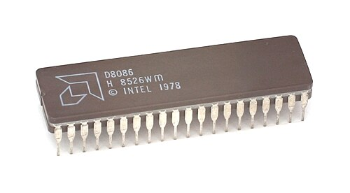
16-bit CPU: The core processing unit that handles all data operations in 16-bit chunks both internally and when communicating with the outside world.
Figure: 16-bit CPU
20-bit Address Bus: Twenty dedicated lines that let the processor reach and identify specific memory locations across the entire address space.
16-bit Data Bus: A parallel pathway that moves two bytes of data at once between the CPU, memory chips, and connected I/O devices.
1 MB Addressing Capability: The system can locate and access up to one megabyte of memory, which equals 2^20 individual bytes.
Monitor Program (ROM Based): Pre-installed system software stored in read-only memory that helps users type in, run, and troubleshoot their programs.
RAM for User Program: Writable memory space on the board where users can load their assembly code and watch it execute in real time.
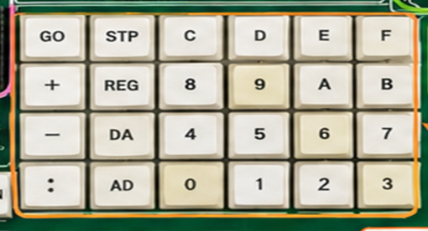
Hexadecimal Keypad: A physical input panel with keys labeled 0 through 9 and A through F for punching in data values, memory addresses, and system commands.
Figure: Hexadecimal Keypad
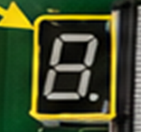
Seven Segment Display: LED digit panels that glow to show address values, stored data, and register contents in hexadecimal format.
Figure: Seven Segment Display
LED Interface: Standalone light-emitting diodes that give instant visual clues about signal status, port activity, or flag conditions.

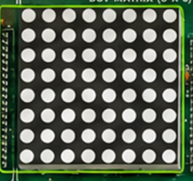
Dot Matrix Display: A grid of tiny LEDs arranged to form readable letters, numbers, and custom-designed symbols.
Figure: Dot Matrix Display
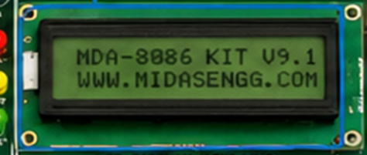
LCD Display: A liquid crystal screen that presents text output and menu options for easier reading and user navigation.
Figure: LCD Display
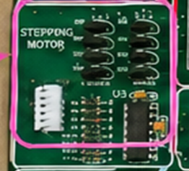
Stepper Motor Interface: A dedicated hardware connection that sends step-by-step control signals to rotate a stepper motor with precision.
Figure: Dot Matrix Display
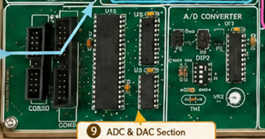
ADC/DAC Interface: Analog-to-digital and digital-to-analog converters that translate real-world analog signals into digital values and vice versa.
Figure: ADC/DAC Interface
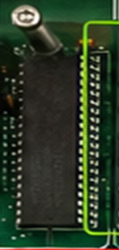
8255 Programmable Peripheral Interface: An external chip that provides parallel input-output ports, allowing the microprocessor to talk to various connected devices.
Figure: 8255 PPI
Standalone Operation: The trainer works entirely on its own without needing a personal computer hooked up to run or test programs.
EPROM (Stores Monitor Program): Non-volatile memory that permanently holds the built-in monitor software responsible for booting the system and managing the keypad and displays.
RAM (Stores User Program): Temporary memory chips that hold the assembly language code and working data written by the user during each session.
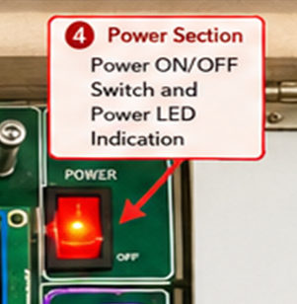
Power Switch (ON/OFF, Power LED): A toggle switch that controls electricity flow to the board, paired with an LED that lights up when the system is powered on.
Figure: Power Switch
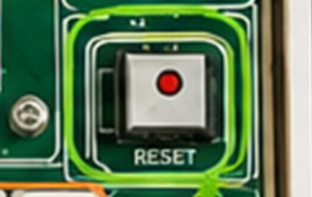
Reset Switch: A pushbutton that clears all internal registers and resets the program counter, returning the CPU to its initial startup state or restarting the current program from the beginning.
Figure: Power Switch

Conclusion: The MDA-8086 trainer kit serves as a practical and self-contained learning environment for mastering 8086 microprocessor concepts. Through direct interaction with hardware components like the keypad, displays, LEDs, and interfacing chips, students gain solid understanding of how assembly instructions translate into real physical actions. The inclusion of the 8255 PPI bridges the gap between the CPU and external devices, demonstrating why peripheral controllers matter in embedded systems. By writing, entering, and executing programs on this standalone platform, learners develop both software and hardware troubleshooting skills essential for microprocessor-based design. Overall, this experiment establishes a strong foundation for advanced studies in computer architecture, embedded systems, and low-level programming.

